Student Record Management System – Step-by-Step Documentation

- Project Title
Student Record Management System (Menu-Driven Python Console Program)

- Objective
The objective of this project is to design and implement a menu-driven Python program using basic Python concepts such as lists, dictionaries, functions, loops, conditions, exception handling, and file handling.

- Project Theme
This project is based on a real-life problem: maintaining student records in an organized and searchable way.

- Data Storage Design
Student records are stored using:
- A list to store multiple student entries
- A dictionary for each student record
Each dictionary includes student details like ID, name, course, semester, and marks.

- Menu-Driven Structure
The program runs using a while loop and continuously displays menu options until the user chooses Exit.
Menu options include:
- Add Student
- View Students
- Search Student
- Delete Student
- Save to File
- Load from File
- Exit

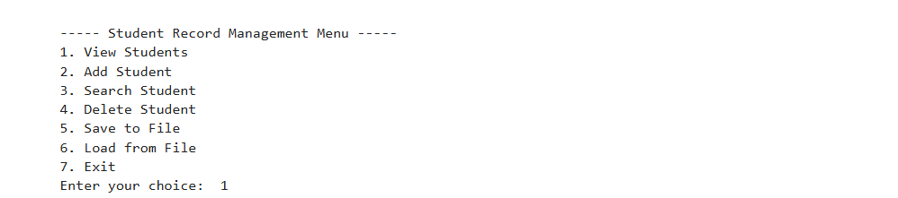

- Step-by-Step Execution with Screenshots

  - View Student Records
- Choose “View Students” option (Type 1 in the search box).
- Program displays all student records available in the system.
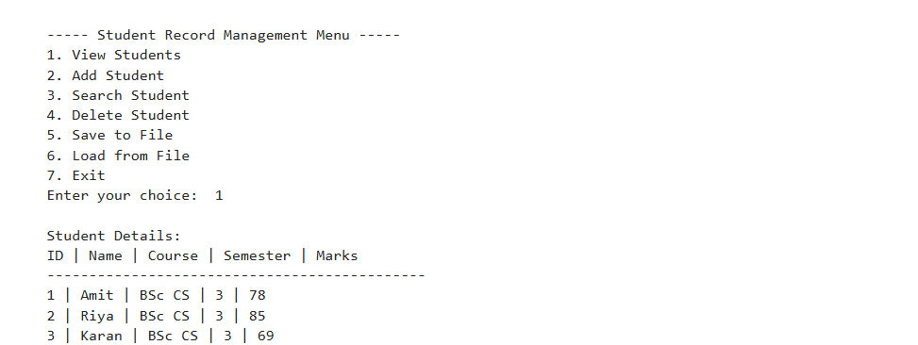

  - Add Student Record
- Choose the “Add Student” option from the menu.
- Enter student ID, name, course, semester, and marks.
- Input validation is applied to avoid invalid entries.
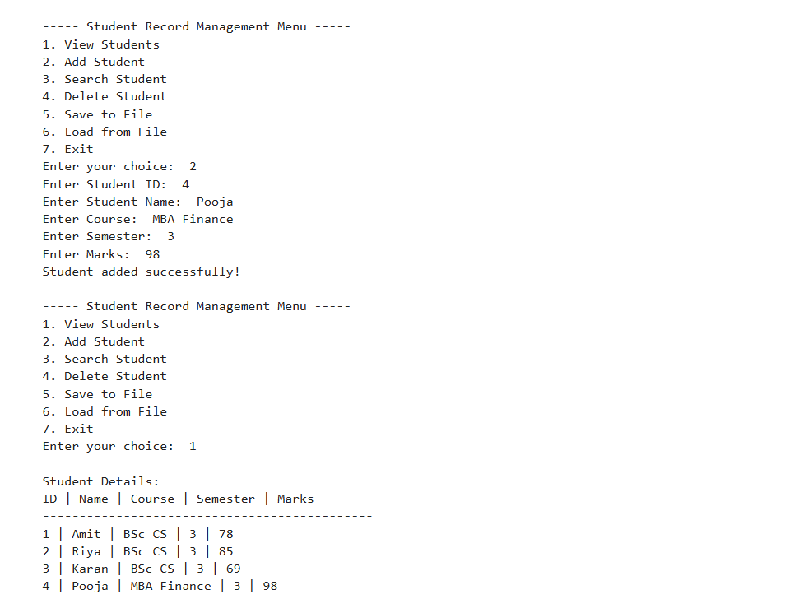

  - Search Student by ID
- Choose “Search Student” option.
- Enter a student ID.
- Program displays the matching record if found, otherwise shows “Not found”.
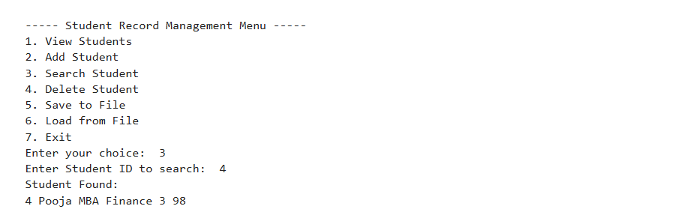

  - Delete Student Record
- Choose “Delete Student” option.
- Enter the student ID to remove the record.
- Program deletes the record safely.
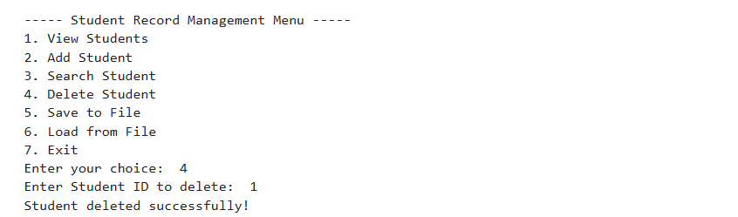

  - Save Data to File
- Choose “Save to File” option.
- Program writes all current records into the data file using file handling.
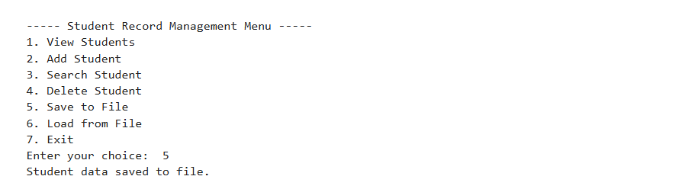

- Python Concepts Used Functions
The project uses multiple user-defined functions such as:
- add_student()
- view_students()
- search_student()
- delete_student()
- save_to_file()
- load_from_file()

- Conditional Statements
Menu selection and validations are handled using if / elif / else.

- Methods Used
- List methods: append(), pop(), len()
- Dictionary methods: get(), keys(), values()
- String methods: strip(), title()

- Exception Handling
try/except is used to handle invalid inputs (example: if user enters text instead of number).
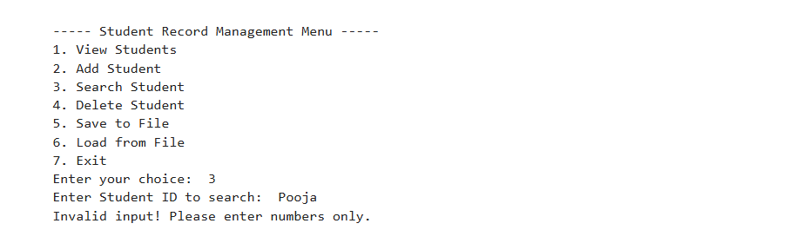

- File Handling
- The program uses open() / with open() to save and load student records from a file.
- Data remains stored even after the program closes.

- Conclusion
This project successfully meets the mini-project requirements. It is menu-driven, uses proper data structures, validates input, handles errors safely, and stores records permanently using file handling.

- Author Details
NAME: Pooja Suresh Hegde
USN: 1BG24BA087
COURSE: Python Programming
PROJECT: Student Record Management System
DOMAIN: Education / Academic Records

